The feasibility of reaching gigatonne scale CO₂ storage by mid-century
Yuting Zhang^{a*}, Christopher Jacksonª, and Samuel Krevorª

ª Department of Earth Science and Engineering, Imperial College London, Exhibition Road, London, SW7 2BX, UK

*Email: yuting.zhang16@imperial.ac.uk

Supplementary Information

Summary: this document includes the full-size figures showing the base results of modelled storage rates across ten selected global storage regions (Figure 2 in main manuscript).

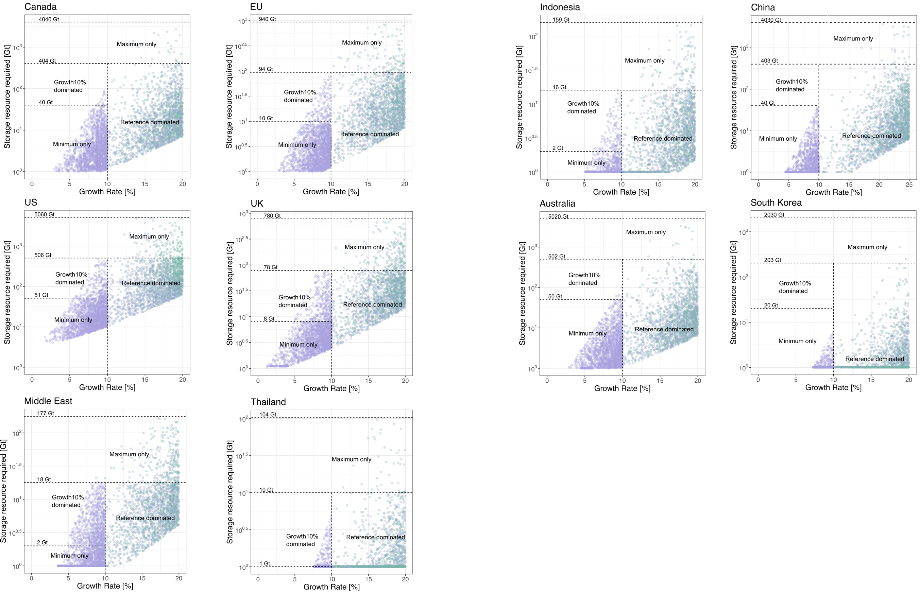
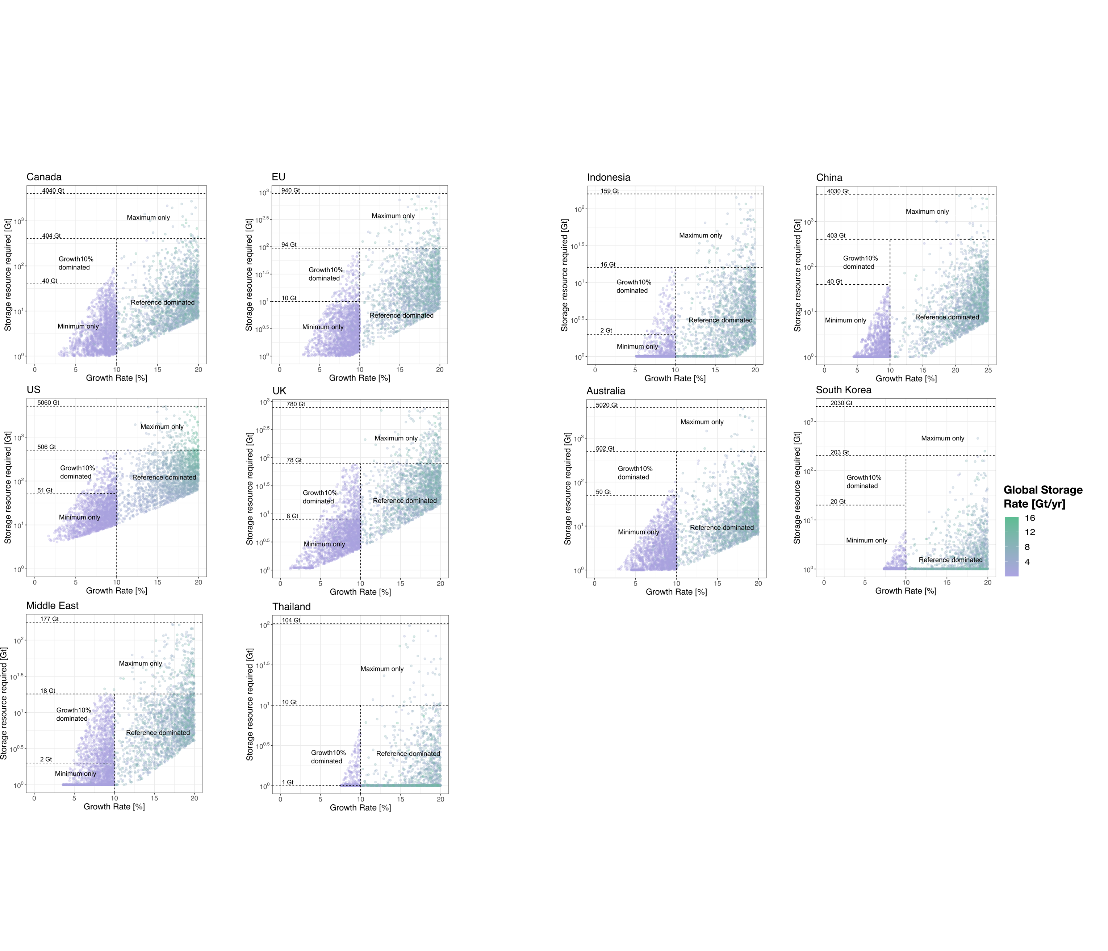
Figure 1: base results of geographically resolved CO₂ storage scale up modelled for ten selected storage regions. The points in the graphs each represent a modelled scaleup trajectory, parameterised by the growth rate and storage resource, and within regions of the graph corresponding to the reference, minimum, maximum and growth10% scenarios described in Table 1 of main manuscript. The colour of each marker shows the combined global storage rate where this trajectory is included. The minimum storage resource requirement established as a function of growth rate reflects the parametrisation of peak year which is constrained to post-2050. This consideration reflects a simple representation that the lack of long-term viability of CO₂ storage deployment as a result of a small storage resource base is precluded by the model.

